****Year 7 Physics

**Investigating Levers: Validation test\***

Student name: ____________________________________

Test materials

* Pen or pencil
* Calculator
* Task 8 Levers Investigation worksheet with **no additional notes or fact sheets**

**Investigation questions**

1. What were the following variables in your experiment? (2 marks)
2. Independent variable: _______________________________________________________________

_________________________________________________________________________________

1. Dependent variable: _______________________________________________________________

_________________________________________________________________________________

1. Look at your results to answer the following questions: (3 marks)
2. What was the furthest distance thrown without the dog ball thrower? ____________
3. What was the shortest distance thrown with the dog ball thrower? ____________
4. What is the difference in the average distance thrown with the dog ball thrower and without the dog ball thrower? Larger number – smaller number = ____________
5. On average, what throwing method made the ball go further? ___________________________

What was the average throw for arm throws? ___________________

What was the average throw for ball thrower throws? ________________

(3 marks)

1. Why does the dog ball thrower often throw further than just the arm? (2 marks)

____________________________________________________________________________________________________________________________________________________________________________________________________________________________________________________________________________________________________________________________________

1. What is one thing you would change about this experiment to make the results more accurate? (2 marks)

___________________________________________________________________________________________________________________________________________________________________________________________________________________________________________________

**Levers**

1. A dog ball thrower is a third class lever. What are the names of the other two types of levers. Give an example of each type. (4 marks)

____________________________________________________________________________________________________________________________________________________________________________________________________________________________________________________________________________________________________________________________________

1. Draw a diagram of a third class lever, labelling the pivot, effort, and load (4 marks)
2. Annotate the following image to show the effort, pivot, load, and motion (4 marks)

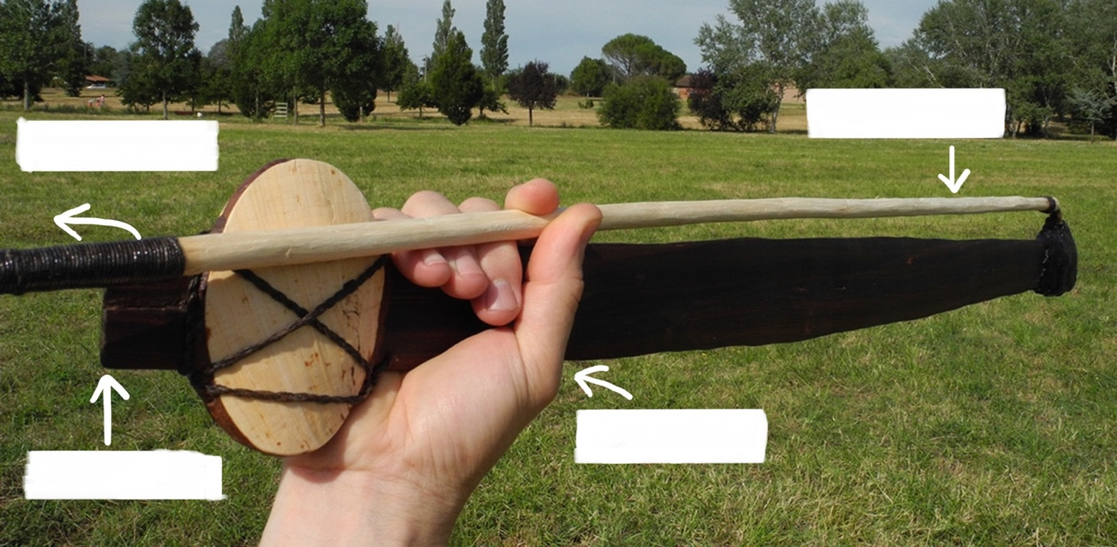

1. How does a spear thrower help the user? What does it do to the spear? (2 marks)

____________________________________________________________________________________________________________________________________________________________________________________________________________________________________________________________________________________________________________________________________

**Organisation:** worksheet brought to class on test date completed and handed in with test (2 marks)